

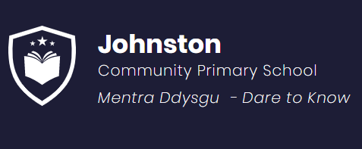

Preventing Extremism Radicalisation Policy

First Release: December 2020
Revised: June 2026

This policy should be read in conjunction with key national and local legislation, guidance and policies.

1. POLICY CONTEXT

The United Kingdom’s Strategy for Countering Terrorism, entitled CONTEST and as referenced in the Counter-Terrorism and Security Act 2015, contains four key work streams: Pursue, Prevent, Protect and Prepare. Each work stream comprises a number of key objectives. This Policy deals with the Prevent work stream only.

Prevent
The aim of the Prevent strategy is to reduce the threat to the UK from terrorism by stopping people becoming terrorists or supporting terrorism. Delivery of Prevent is grounded in early intervention and safeguarding. Radicalisation is the process of a person subscribing to extremist ideology. This can include legitimising support for, or use of, terrorist violence. The majority of people who commit terrorism offences do so of their own agency and dedication to an ideological cause.

The full guidance is available at: Prevent duty guidance: Guidance for specified authorities in England and Wales
The Guidance also states for England and Wales the obligations for specified authorities to have due regard to the need to prevent people from being drawn into terrorism.

2. POLICY STATEMENT

Johnston C.P. School is fully committed to safeguarding and promoting the welfare of all its pupils. Every member of staff recognises that safeguarding against radicalisation and extremism is no different to safeguarding against any other vulnerability in today’s society. The Preventing Extremism and Radicalisation Policy sets out our beliefs, strategies and procedures to protect vulnerable individuals from being radicalised or exposed to extremist views, by identifying who they are and promptly providing them with support.

3. AIMS AND PRINCIPLES

The Johnston C.P. School’s Preventing Extremism and Radicalisation Policy is intended to provide a framework for dealing with issues relating to vulnerability, radicalisation and exposure to extreme views. We recognise that we are well placed to be able to identify safeguarding issues and this policy clearly sets out how the school will deal with such incidents and identifies how the curriculum and ethos underpins our actions.
The objectives are that:
- All governors, teachers, teaching assistants and non-teaching staff will have an understanding of what radicalisation and extremism are is and why we need to be vigilant in school.
- All governors, teachers, teaching assistants and non-teaching staff will know what the school policy is on tackling extremism and radicalisation and will follow the policy guidance swiftly when issues arise.
- All pupils will understand the dangers of radicalisation and exposure to extremist views; building resilience against these and knowing what to do if they experience them.
- All parents/carers and pupils will know that the school has policies in place to keep pupils safe from harm and that the school regularly reviews its systems to ensure they are appropriate and effective.

The main aims of this policy are to ensure that all staff are fully engaged in being vigilant about radicalisation; that they overcome professional disbelief that such issues will not happen here and ensure that we work alongside other professional bodies and agencies to ensure that our pupils are safe from harm.

4. INDICATORS OF VULNERABLITY TO RADICALISATION

Radicalisation refers to the process by which a person comes to support terrorism and forms of extremism leading to terrorism. Extremism is defined by the Government in the Prevent Strategy as:

Vocal or active opposition to fundamental British values, including democracy, the rule of law, individual liberty and mutual respect and tolerance of different faiths and beliefs. We also include in our definition of extremism calls for the death of members of our armed forces, whether in this country or overseas.

Extremism is defined by the Crown Prosecution Service as:
The demonstration of unacceptable behaviour by using any means or medium to express views which:

- encourage, justify or glorify terrorist violence in furtherance of particular beliefs;
- seek to provoke others to terrorist acts;
- encourage other serious criminal activity or seek to provoke others to serious criminal acts; or
- foster hatred which might lead to inter-community violence in the UK.

There is no such thing as a “typical extremist”. Those who become involved in violent extremist actions come from a range of backgrounds and experiences, and most individuals, even those who hold radical views, do not become involved in violent extremist activity.

Pupils may become susceptible to radicalisation through a range of social, personal and environmental factors. It is known that violent extremists exploit vulnerabilities in individuals to drive a wedge between them and their families and communities, i.e. to create a ‘them’ and ‘us’ mentality. It is vital that all school staff are able to recognise those vulnerabilities.

Indicators of vulnerability include:

- Identity Crisis – the student/pupil is distanced from their cultural/religious heritage and experiences discomfort about their place in society;
- Personal Crisis – the student/pupil may be experiencing family tensions; a sense of isolation; and low self-esteem; they may have dissociated from their existing friendship group and become involved with a new and different group of friends; they may be searching for answers to questions about identity, faith and belonging;
- Personal Circumstances – migration; local community tensions; and events affecting the student/pupil’s country or region of origin may contribute to a sense of grievance that is triggered by personal experience of racism or discrimination or aspects of Government policy;
- Unmet Aspirations – the student/pupil may have perceptions of injustice; a feeling of failure; rejection of civic life;
- Experiences of Criminality – which may include involvement with criminal groups, imprisonment, and poor resettlement/reintegration;
- Special Educational Need – students/pupils may experience difficulties with social interaction, empathy with others, understanding the consequences of their actions and awareness of the motivations of others.

However, this list is not exhaustive, nor does it mean that all young people experiencing the above will encounter radicalisation for the purposes of violent extremism.

More critical risk factors could include:

- being in contact with extremist recruiters;
- accessing violent extremist websites, especially those with a social networking element;
- possessing or accessing violent extremist literature;
- using extremist narratives and a global ideology to explain personal disadvantage;
- justifying the use of violence to solve societal issues;
- joining or seeking to join extremist organisations;
- significant changes to appearance and/or behaviour;
- experiencing a high level of social isolation resulting in issues of identity crisis and/or personal crisis.

5. PROCEDURES FOR REFERRALS
It is important for us to be constantly vigilant and remain fully informed about the issues which affect the local area, city and society in which we work and live. Staff are reminded to suspend any ‘professional disbelief’ that instances of radicalisation ‘could not happen here’ and to be ‘professionally inquisitive’ where concerns arise, referring any concerns through the appropriate channels. (See Appendix 1 – Dealing with Referrals)

We believe that it is possible to intervene to protect people who are vulnerable. Early intervention is vital and staff must be aware of the established processes for front line professionals to refer concerns about individuals and/or groups. We must have the confidence to challenge and to intervene and ensure that we have strong safeguarding practices based on the most up-to-date guidance and best practise.

Designated Senior Leaders for Safeguarding will be appropriately trained in identifying potential radicalisation and extremism and will deal swiftly with any referrals made by staff or with concerns reported by staff.

The Headteacher/Designated Senior Person (DSP) will discuss the most appropriate course of action on a case-by-case basis and will decide when a referral to external agencies is needed (see Appendix 1 – Dealing with Referrals). Advice can always be sought from the Child Care Assessment Team.
As with any child protection referral, staff must be made aware that if they do not agree with a decision not to refer, they can make the referral themselves and will be given the contact details to do this via the safeguarding board in the staffroom.

6. GOVERNORS, LEADERS & STAFF

The Head teacher and all other members of the Senior Leadership Team (SLT)/ and DSP are the leaders for referrals relating to extremism and radicalisation. In the unlikely event that SLT members are not available, all staff know the channels by which to make referrals via the safeguarding board in the staffroom.

Staff will be fully briefed about what to do if they are concerned about the possibility of radicalisation relating to a pupil, or if they need to discuss specific children whom they consider to be vulnerable to radicalisation or extremist views.

The SLT/DSP will work in conjunction with the Headteacher, Pastoral Care Team and external agencies to decide the best course of action to address concerns which arise.

Prejudicial behaviour can be a factor in radicalisation and extremism. With this in mind, Johnston C.P. School has updated procedures for dealing with prejudicial behaviour, as outlined in the Positive Behaviour Policy and Strategic Equality Plan/Policy.

7. THE ROLE OF THE CURRICULUM
Our curriculum is “broad and balanced”. It promotes understanding, respect, tolerance and diversity. Children are encouraged to share their views and recognise that they are entitled to have their own different beliefs which should not be used to influence others.

Our PSHE provision is embedded across the curriculum. It directs our assemblies and underpins the ethos of the school. We strive to equip our pupils with confidence, self-belief, respect and tolerance as well as setting high standards and expectations for themselves.

Children are taught about how to stay safe when using the internet and are encouraged to recognise that people are not always who they say they are online. They are taught to seek adult help if they are upset or concerned about anything they read or see on the internet.

8. STAFF TRAINING

Through INSET opportunities in school, we will ensure that our staff are fully aware of the threats, risks and vulnerabilities that are linked to radicalisation; are aware of the process of radicalisation, how this might be identified early on and how we can provide support as a school to ensure that our children think critically, develop self-esteem, global citizenship, resilience and are thus able to resist involvement in radical or extreme activities.
All school staff must complete the mandatory Radicalisation PREVENT module on POD.
In addition to this, staff are also required to complete ACT for Education on POD.

ACT for Education e-Learning
Action Counters Terrorism (ACT) for Education e-learning is bespoke training aimed at all staff working in education settings (Early Years through to the Further and Higher Education). The seven modules in this course focus on embedding a security minded culture, identifying security vulnerabilities and suspicious activity and responding to incidents using core principles such as Run, Hide, Tell, the HOT Protocol and the power of hello. We recommend you read the Protective Security and Preparedness Guidance for education settings guidance to embed your learning.

Protective Security and Preparedness for education settings guidance
This non-statutory guidance offers simple, practical and low-cost steps that settings can take to deter attacks and develop effective plans to keep learners and staff safe in the event of an incident. It is aimed at all those who have responsibilities for keeping learners safe and security leads and includes advice on developing response plans, testing and exercising and communications.
Protective security and preparedness for education settings - GOV.UK

9. VISITORS AND THE USE OF SCHOOL PREMISES

If any member of staff wishes to invite a visitor in the school, they must first complete the appropriate documentation. Only after written agreement from the Headteacher can the visitor enter school and then they will be subject to Safeguarding Checks including DBS checks and photo identification. Children are NEVER left unsupervised with external visitors, regardless of safeguarding check outcomes.

Upon arriving at the school, all visitors including contractors, will read the child protection and safeguarding guidance and be made aware of who the DSLs are and how to report any concerns which they may experience.

If any agreement is made to allow non-school groups or organisations to use the premises, appropriate checks will be made before agreeing the contract. Usage will be monitored and in the event of any behaviour not in-keeping with the Tackling Extremism and Radicalisation Policy, the school will contact the police and terminate the contract.

(School / Service) values freedom of speech and the expression of beliefs and ideology as fundamental rights underpinning our society’s values. Both pupils/students and teachers have the right to speak freely and voice their opinions. However, freedom comes with responsibility and free speech that is designed to manipulate the vulnerable or that leads to violence and harm of others goes against the moral principles in which freedom of speech is valued. Free speech is not an unqualified privilege; it is subject to laws and policies governing equality, human rights, community safety and community cohesion.

The current threat from terrorism in the United Kingdom may include the exploitation of vulnerable people, to involve them in terrorism or in activity in support of terrorism. The normalisation of extreme views may also make children and young people vulnerable to future manipulation and exploitation. Johnston C.P. School is clear that this exploitation and radicalisation should be viewed as a safeguarding concern.

Definitions of radicalisation and extremism, and indicators of vulnerability to radicalisation are in the Appendix 2.

Johnston C.P. School seeks to protect children and young people against the messages of all violent extremism including, but not restricted to, those linked to extremist Islamist ideology, or to Far Right/Neo-Nazi/White Supremacist ideology.
10. RISK REDUCTION AND RESPONSE

The school governors, the Headteacher and the Designated Safeguarding Lead will assess the level of risk within the school and put actions in place to reduce that risk. Risk assessment may include consideration of the school’s RE curriculum, PSHE policy, assembly policy, use of school premises by external agencies, integration of pupils by gender and SEN, anti-bullying policy and other issues specific to the school’s profile, community and philosophy.

Our school, will identify a Prevent Single Point of Contact (SPOC) who will be the lead within the organisation for safeguarding in relation to protecting individuals from radicalisation and involvement in terrorism: this will normally be the Designated Safeguarding Person. The SPOC for Johnston C.P. School is Ross Williams. The responsibilities of the SPOC are described in Appendix 3.

When any member of staff has concerns that a pupil may be at risk of radicalisation or involvement in terrorism, they should speak with the SPOC and to the Designated Safeguarding Lead if this is not the same person.

Numerous factors can contribute to and influence the range of behaviours that are defined as violent extremism, but most young people do not become involved in extremist action. For this reason the appropriate interventions in any particular case may not have any specific connection to the threat of radicalisation, for example they may address mental health, relationship or drug/alcohol issues

11. MULTI-AGENCY CHANNEL PANELS IN PEMBROKESHIRE

Pembrokeshire’s duties in respect of Channel Panels will be discharged on a multi-agency basis and will adhere to the Prevent Strategy and Channel Duty Guidance.
Full Guidance can be found at: Channel Duty Guidance: Protecting people susceptible to radicalisation

The multi-agency Safeguarding Children Operational Partnership will provide the arena and governance for Channel Panels and their agreement.

12. POLICY REVIEW

Individual School Review
12.1 The Johnston C.P. School Tackling Extremism and Radicalisation Policy will be reviewed annually as part of the overall Child Protection and Safeguarding policy review.

12.2 Preventing Extremism and Radicalisation Policy Review
This Policy will be reviewed on an annual basis by the multi-agency Pembrokeshire Safeguarding Children Operational Partnership (Channel Panel).

12.3 This policy will be ratified by the Governing Body.

Signed……………………………………….. (Chair of Governors)

Date……………………………………….......

Appendix 1

Dealing with Referrals

If there is a reason to believe that a child, young person or an adult associates with those known to be involved in extremism either because they associate directly with known individuals or because they frequent key locations, including online material, where these individuals are known to operate, there is a need to refer to the Prevent via a Multi Agency Reporting Form (MARF).
By completing the MARF you consent for the referral to arrive with both the Local Authority safeguarding team & Prevent policing team for a joint assessment. Wherever possible we aim to give you feedback on your referral, please be aware, however, that this is not always possible.
All Prevent referrals are triaged in the first instance by specialist police officers and staff. These officers determine whether there are reasonable grounds to suspect that a person is at risk of radicalisation, and therefore appropriate for support through Prevent. This ‘gateway assessment’ draws upon police databases and other resources to determine the level of susceptibility and risk around the referred person, and whether they are appropriate for Prevent.

Pembrokeshire Channel Panel
The role of the Channel panel is to develop an appropriate support package to safeguard those at risk of being drawn into extremism based on an assessment of their vulnerability. The panel is made up of a number of professionals with safeguarding experience from a variety of organisations and services including children and adults safeguarding, education, health, and Dyfed Powys Police.
Channel uses a multi-agency approach to:
• identify people at risk
• assess the nature and extent of that risk
• develop the most appropriate support plan for the person concerned.
For support or concerns about someone being radicalised information and help can be found on the Home Office website.

When assessing terrorism susceptibility, consideration should be given to contextual safeguarding principles, and the full range of relevant indicators, influencing factors and relationships that may have an impact on a person’s level of risk, individual agency, and any associated vulnerabilities. This may include direct contact with extremists, community, family influences or the influence of wider networks, such as materials sourced via online or social media platforms. The panel should consider alignment and co-ordination with other support structures, available to address wider safeguarding needs (e.g. Multi-Agency Risk Assessment Conference or a child in need plan), though these should be in parallel with rather than in place of Channel.
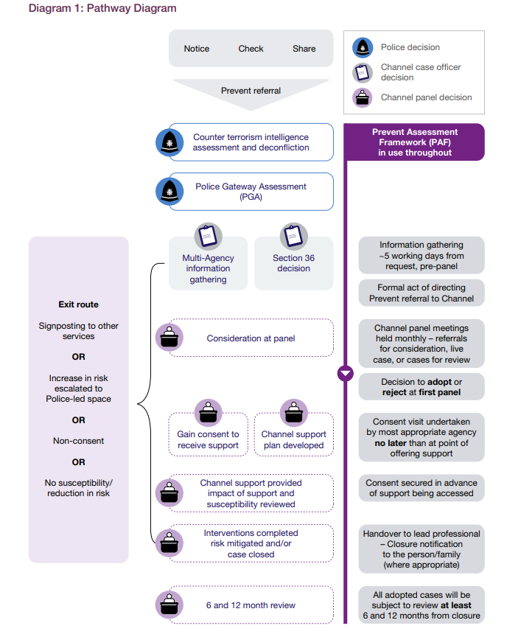
For full details of Channel Panel guidance please visit: Channel Duty Guidance: Protecting people susceptible to radicalisation

Appendix 2

Definitions of Radicalisation and Extremism

Radicalisation is the process by which an individual or group comes to adopt increasingly extreme political, social, or religious ideals and aspirations that reject or undermine the status quo or contemporary ideas and expressions of the nation. This process can lead to the support for, or participation in, activities that are considered extreme or violent.

Extremism:
Extremism refers to the holding of extreme political or religious views that are far removed from the mainstream attitudes of society. These views often advocate for radical changes and can sometimes lead to the endorsement or use of violence to achieve ideological goals.

PREVENT: Prevent deals with all kinds of terrorist threats to the UK.
Prevent’s first objective is to tackle the ideological causes of terrorism. The ideological component of terrorism is what sets it apart from other acts of serious violence. Islamist ideology is resilient and enduring. Extreme Right-Wing ideology is resurgent. Other ideologies are less present, but still have the potential to motivate, inspire and be used to justify terrorism.

Appendix 3

Responsibility of DSP /Prevent Lead
Keeping Learners Safe (Keeping learners safe | GOV.WALES) guidance outlines the critical role of the Designated Safeguarding Person (DSP) in schools and educational settings, particularly in relation to the PREVENT strategy and Channel panels. The key responsibilities are:
- Identifying Concerns: The DSP is responsible for identifying and assessing concerns related to radicalisation and extremism. They should be vigilant and aware of the signs that a learner may be at risk
- Making Referrals: If the DSP identifies a learner at risk, they are responsible for making a referral to the Channel panel. This involves providing detailed information about the concerns and the context i.e. family structure, learning ability, social influences / friendships.
- Multi-Agency Collaboration: The DSP should work closely with other agencies, including the police, social services, and the Channel panel, to ensure a coordinated approach to safeguarding.
- Implementing Support Plans: Once a support plan is developed by the Channel panel, the DSP ensures it is implemented effectively within the educational setting. This may involve coordinating with teachers, parents, and other stakeholders
- Training and Awareness: The DSP is responsible for ensuring that all staff members are trained to recognise and respond to signs of radicalisation. They should also promote awareness of the PREVENT strategy within the school community.
- Monitoring and Review: The DSP monitors the progress of learners who are receiving support and reviews the effectiveness of the interventions. The DSP should provide updates to the Channel panel as needed / requested.

Appendix 4:
Martyn’s Law

Premises and events will be better prepared to respond to attacks as landmark legislation known as Martyn’s Law gained Royal Assent and became law today (Thursday 3 April). The Terrorism (Protection of Premises) Act 2025 will require public premises where 200 or more individuals may be present, to be better prepared and have plans in place to keep people safe in the event of an attack.
Appendix 4: Martyn’s Law

Premises and events will be better prepared to respond to attacks as landmark legislation known as Martyn’s Law gained Royal Assent and became law today (Thursday 3 April). The Terrorism (Protection of Premises) Act 2025 will require public premises where 200 or more individuals may be present, to be better prepared and have plans in place to keep people safe in the event of an attack.
Enhanced duty requirements will not apply to premises used for childcare or primary, secondary, or further education.
These premises are different to other premises within scope. There are existing safety and safeguarding policies and procedures which establish a range of procedures and measures, for example regarding access control measures and evacuation procedures.
However, these premises can be subject to attack, and establishing a basic legal minimum requirement for procedures is regarded as helpful by Government.
The operating environment for these establishments is significantly different to higher education premises which are usually more openly accessible to members of the public and are more frequently used for events. As such higher education establishments are treated the same as other premises in scope.

ACT for Education | ProtectUK

ACT for Education e-Learning
Action Counters Terrorism (ACT) for Education e-learning is bespoke training aimed at all staff working in education settings (Early Years through to the Further and Higher Education). The seven modules in this course focus on embedding a security minded culture, identifying security vulnerabilities and suspicious activity and responding to incidents using core principles such as Run, Hide, Tell, the HOT Protocol and the power of hello. We recommend you read the Protective Security and Preparedness Guidance for education settings guidance to embed your learning.

Protective Security and Preparedness for education settings guidance
This non-statutory guidance offers simple, practical and low-cost steps that settings can take to deter attacks and develop effective plans to keep learners and staff safe in the event of an incident. It is aimed at all those who have responsibilities for keeping learners safe and security leads and includes advice on developing response plans, testing and exercising and communications.
Protective security and preparedness for education settings - GOV.UK
Read more here: https://matomo.protectuk.police.uk/2a8ffb

Appendix 5

Information for Parent/ Carers

’Prevent: Prevent and Countering Extremism in Young People Advice and Guidance for Parents and Carers is available at: Parents' Booklet

