d
Ysgol Gynradd Gymunedol Johnston
Community Primary School

2025-2026 GOVERNORS’ ANNUAL REPORT TO PARENTS

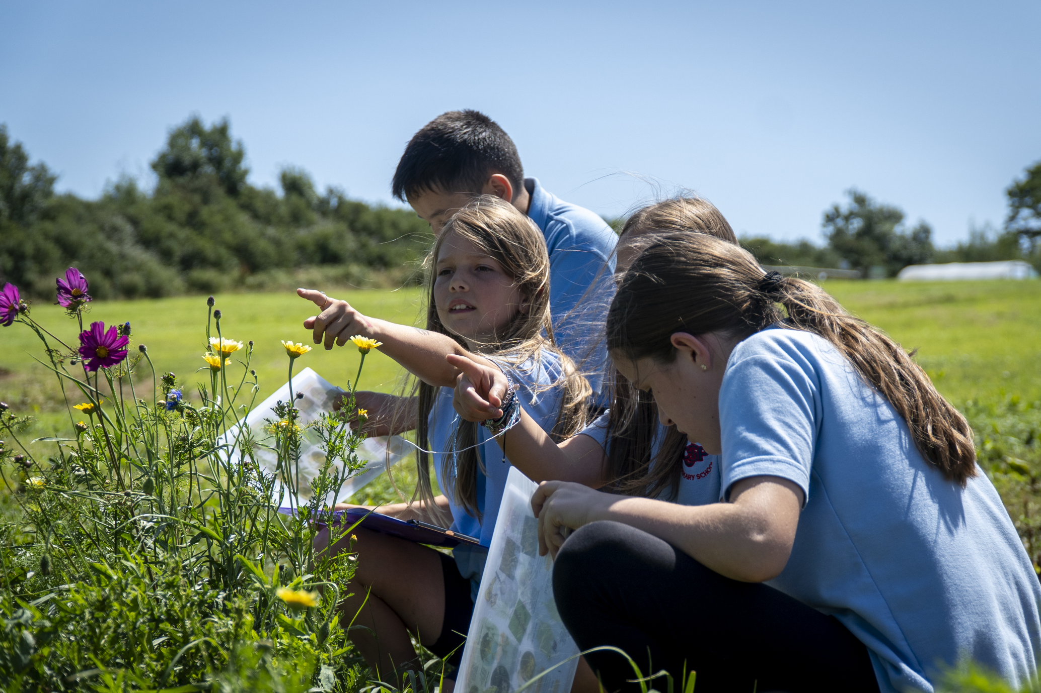

A forward-looking school that provides a nurturing environment for all, with a creative and engaging curriculum steeped in learning opportunities and experiences linked to real world matters encouraging all pupils to achieve their potential in everything they do.

Chair of Governors Cllr Aled Thomas
c/o Johnston Community Primary school
Langford Road SA623PY

Clerk to Governors
Mr Steven Richard-Downes
County Hall
Haverfordwest
SA611TP

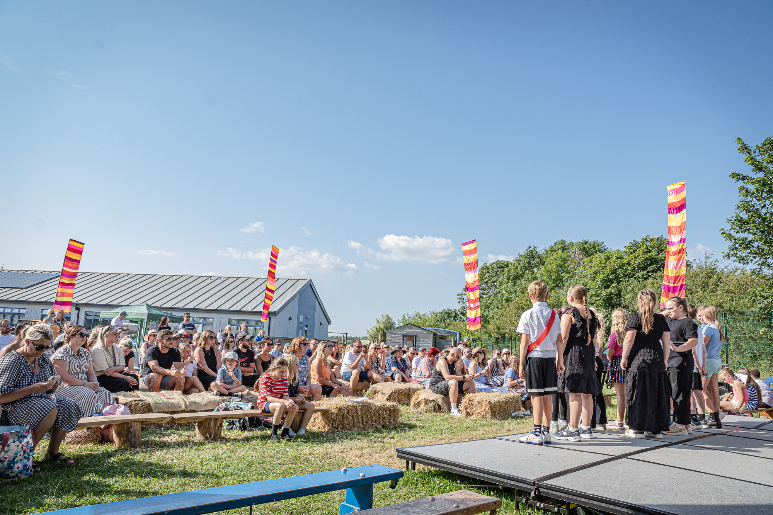Dear Parents/Guardians,

I am delighted to present the Governing Body’s Annual Report for the academic year.

As governors, we regularly visit Johnston C.P. School throughout the year to monitor progress against the school’s priorities and to gain first-hand insight into school life. These visits provide valuable opportunities to meet with staff and pupils, observe learning, and celebrate achievements. One of the highlights of our visits is spending time with the children and discussing their work. We are consistently impressed by their confidence, enthusiasm, and ability to reflect thoughtfully on their learning. It is clear that they take great pride in their achievements and enjoy sharing their successes with others.

At Johnston C.P. School, pupil voice remains an important part of school life. Children are encouraged to share their ideas, reflect on their learning, and contribute to decisions that help shape the school community. During our visits, pupils speak confidently about their experiences and demonstrate a strong sense of ownership and pride in their school. These opportunities help to develop confidence, responsibility, and the skills needed to become active and engaged learners.

The school continues to provide a rich and ambitious curriculum that inspires curiosity and a love of learning. This year, there has been an increased focus on developing reading across the school, helping pupils to build strong literacy skills while fostering a genuine enjoyment of books and storytelling. Alongside this, the school has continued to strengthen its knowledge-rich curriculum, ensuring that pupils develop a broad understanding of the world and acquire the knowledge and vocabulary needed to succeed in their future learning. Learning is further enriched through outdoor activities, educational visits, and memorable experiences that bring the curriculum to life. Throughout the year, pupils have enjoyed a range of exciting opportunities, including beach exploration, stargazing activities, and Forest School sessions. Older pupils have also benefited from residential visits and outdoor adventure experiences, helping them to develop independence, resilience, and confidence.

This year has also been marked by some wonderful opportunities for pupils to showcase their talents. Our theatre evening at the end of term was a particular highlight, bringing together pupils, staff, families, and the wider community for a memorable celebration of creativity and performance. The confidence, enthusiasm, and talent displayed by the children on stage were remarkable, and the event reflected the strong sense of community that makes Johnston C.P. School such a special place.

Johnston C.P. School continues to flourish as a nurturing, ambitious, and successful learning community. Pupils achieve highly across the curriculum and take part enthusiastically in the many opportunities available to them. The school's continued success is built upon the dedication of staff, the hard work of pupils, and the invaluable support provided by families and the wider community. It is a pleasure to see the school continue to grow and develop while maintaining its warm and inclusive ethos.

On behalf of the Governing Body, I would like to express our sincere thanks to all members of staff for their unwavering commitment and hard work throughout the year. We also thank our pupils for their enthusiasm, positivity, and determination, and our families for the continued support they provide to the school. Finally, I would like to thank my fellow governors for their dedication and service in supporting the school and helping to ensure the very best outcomes for all pupils.

Yours sincerely,

Cllr Aled Thomas (Chair of Governors)

Your right to request a meeting with the school’s governing body

The Schools Standards and Organisation (Wales) Act 2013 (The Act) removed the requirement for school governing bodies to hold an annual meeting with parents. Instead, parents can request up to 3 meetings in any school year with a governing body, on matters which are of concern to them. If parents wish to use their rights under the Act to hold a meeting, 4 conditions will need to be satisfied:

- Parents will need to raise a petition in support of holding a meeting.
The parents of at least 10% of the school’s registered pupils will need to sign the petition. If it is a paper petition, then a written signature must be given as well as the name and class of each child who is a registered pupil at the school. If the petition is in electronic format, the ‘signature’ required is the typed name of the parent plus the name and class of each child who is a registered pupil at the school and the email address of each parent who ‘signs’ the electronic petition.

There were 258 registered as pupils with this School at the beginning of this academic year. Exact roll numbers at any time during the year may be obtained from the school office.

- The meeting must be called to discuss matters which affect the School.
The meeting cannot be called to discuss such matters as the progress of individual pupils, or to make a complaint against a member of the school’s staff or governing body. The petition should contain brief details of the matter(s) to be discussed and the reasons for calling the meeting. This information should be clearly displayed at the top of the petition, with parents’ signatures appearing below.

- The law allows parents to use their rights to request up to a maximum of 3 meetings with a school governing body during the school year.

- The law makes it a condition that at least 25 school days are left in the school year when the petition is received so that the meeting can be held.

A “school day” means a day when the school is open to pupils: it does not include weekends, public holidays, school holidays or INSET days.

The address for service of a petition requesting a meeting with this school’s
Governing Body is:
Chair of Governors
Cllr Aled Thomas.
Johnston Community Primary School
Langford Road
Johnston
Haverfordwest
SA62 3PU

Email to the Chair of the Governing Body or; Admin.Johnston@pembrokeshire.gov.uk

Further advice on how parents wish may to go about requesting a meeting with a governing body is available on the Welsh Government’s website at:

http://wales.gov.uk/topics/educationandskills/publications/guidance/parentsmeetingsstatutory- guidance/?lang=e

The full list of governors is as follows:

Name Status
Mr. R. Williams Headteacher
Cllr. Aled Thomas (Chair of Governors) LEA Governor
Mr. S. Roberts Parent Governor
Mrs. B. A. Evans Robertson Parent Governor
Mr. P. Sheward-Himpson Parent Governor
Mr. T. S. Smedley LEA Governor
Mrs. T. D. Young (Vice Chair) Community Governor
Mrs. H Davies Teacher Governor
Ms R Pearce Staff Governor
Mrs Kirsty Coaker Parent Governor
Mr Chris Oliver LEA Governor
Miss Jade Hughes LEA Governor

Election of Parent Governors:
From time to time, vacancies occur for parent representatives on the Governing Body. Any parent of a pupil registered at a school is eligible to stand as a candidate. All parents of children at the school have the opportunity to participate in the election if one is deemed necessary. The election will take the form of a secret ballot and parents are able to vote returning the ballot paper to school in a sealed envelope marked ‘voting paper’, with a pupil or by post. The LA will make the necessary arrangements for the election. Arrangements are made for the election of parent governors one school term before a parent governor’s term of office expires, or on receipt of a resignation. Information about parent elections is sent to parents via Seesaw.

Full Governing Body Meetings:
There is a requirement for the full Governing Body to meet termly (three times a year). These meetings have an agenda that is largely prescribed by the statutory requirements.

The autumn term meeting confirms the Chair and the Vice Chair.

Minutes can be requested to view, in writing, from the Chair of Governors,.

Sub-committee Groups:
The sub-committee groups usually meet termly prior to the full Governing Body meetings. Each has its own terms of reference and are reviewed and agreed at the start of each year. Our subcommittees are;

- Standards and Curriculum
- Health and Safety.
- Finance and Staffing Committee

Previous AGPM:
An Annual Parents’ Meeting was not requested nor held during the 2024-2025 academic year.
Admissions Policy:
School Admissions at Johnston Community Primary School are managed by Pembrokeshire Local Authority. Further information on the policy and how to transfer or apply for a school place can be found on the following website;

https://www.pembrokeshire.gov.uk/school-admissions

Language Category:
Johnston Community Primary School is a designated English Medium school.

Staff
Autumn 2025
Headteacher: Mr. R.L. Williams
Deputy Headteacher: Mr. M. Cheung
Assistant Head teacher: Mrs. C. Wood
ALNCO: Mr. A Stephens
Class Teachers: Miss A. Stephens Year 6
Mr. M. Cheung /Mrs Roach-John Year 5
Mr. A. Jones Year 4
Mrs. J. Lane Year 3
Mrs. H. Davies Year 2
Ms J. Eldred Year 1
Miss J. Thomas/ Mrs Gainfort Early Years

Miss Pearce Early Years

LRC Mrs C.Wood LRC1

Mr T Davies LRC 2

Learning Support Assistants:
Key Stage Two Support Staff:
Mrs. Rees
Miss Calver
Mrs Strand
Miss McQuarrie
Mrs Grant
Mrs Owen
Mrs Elliot
Mrs. Dixon
Mrs. Evans
Ms. Denton
Mrs. Smith
Mrs. Glynn
Miss. Lewis
Miss Howell
Mrs. Wealthall
Miss Christopher
Miss. Wilson
Miss Lee
Mrs Walters
Miss Maddocks

Administrative Officer: Mrs. D Williams Admin Assistant Mrs. T Gardiner
FLO/ALN Support: Mrs. L Greenish
Caretaker Mrs Bradford
Cleaners: Mrs. Bradford & Mr Forlena
Midday Supervisors: Miss. S. Codd
After School Club: Mrs. L Jones & Miss. S. Codd

Term |  | Begin | End | Mid-term break
Term |  | Begin | End | Begin | End
Autumn  2025 |  | Monday 1  September  2025 | Friday 19th December 2025 | Monday 27  October  2025 | Friday 31 October  2025
Spring  2026 |  | Monday 5  January  2026 | Friday 27  March 2026 | Monday 16  February  2026 | Friday 20  February  2026
Summer  2026 |  | Monday 13  April  2026 | Monday 20th July 2026 | Monday 25  May  2026 | Friday 29  May  2026
 | Total |  |  |  |  | 195
Term Dates 2025-26

Numbers on roll
 | part time | full time | Full Time  Equivalent
Autumn 24 | 30 | 220 | 225
Spring 25 | 30 | 227 | 237
Summer 25 | 27 | 225 | 260
Autum25 | 19 | 224.5 | 232
Spring 26 | 25 | 230 | 250
Summer 26 | 32 | 232 | 252

Attendance of Years 1 to 6 pupils
 | Attendance | Authorised Absence | Unauthorised Absence | Attendance
 |  |  |  | FSM | non FSM
School 2019/20  (Prior to lockdown) | 94.6 | 4.56 | 0.85 | 92.3 | 95.14
School 2020-21 | 90.8 | 6.44 | 2.76 | 85.09 | 92.17
School 2021-22 | 90.8 | 7.8 | 1.4 | 87.57 | 91.51
School 2022-2023 | 91.3 | 7.6 | 1.1 | 86.7 | 92.1
School 2023-2024 | 90.99 | 7.50 | 1.09 | 87.13 | 91.89
School 2024-2025 | 92.13 | 6.19 | 3.59
School 2025-2026 | 92.41 | 5.7 | 1.89

Attendance
Our school target for attendance is 95%

School Development Plan Priorities’ 2025-2026
- Improve provision and accelerate skills progression across the curriculum, with a focus on effective feedback and a developing awareness of Learner Effectiveness
- To continue to develop reading provision, focusing on phonics, fluency and vocabulary development and provision across the school.
- To continue to improve pupils Welsh Language skills, improving the quality of provision across the school and supporting our aspiration to teach 10% of the curriculum through the medium of Welsh.
- To continue to develop and improve the teaching and learning of mathematics, ensuring that all pupils are making good or better progress from starting points.

Pupil Participation, sporting and extra-curricular provision
Sports are provided both through the curriculum and through extra-curricular provision. Year 5 and 6 pupils have the opportunity to attend a residential visit which includes outdoor and adventurous activities through the URDD. Provision for learning in arts and music are also through both lessons and extra-curricular activities. These include visiting artists and drama workshops and our school music lessons, as well as our partnership with Pembrokeshire Music Service who deliver peripatetic instrument lessons. The school also provides a range of after school activities including Gardening club, Crew Cymraeg and Folk Dancing.

Community Links
Being a community focused school means being active within our community and being a focus of activity and learning for the community. During the last year these links have continued to be expanded through the use of technology as a way of developing partnerships as well as a return to visitors to the school.
A big thank you to all our community partners:
• Milford Haven cluster of schools who work in close collaboration to ensure consistency of approach and policy for curriculum, teaching and learning.
• Springboard adult and family learning courses are free and open to all our parents.
- St Peters Church and Rev Marcus Zipperlen provides regular visits and support
• The school council choose charities to support throughout the year, including Children in Need.
• The school hosts and collaborates with many external and educational agencies and shares best practice with other PCC schools and across the region
• Darwin Science, supported by Dragon LNG, are key to the provision of science in the curriculum.
• The Police Community Liaison Officer delivers workshops on a range of subjects connected to personal safety and citizenship. The following curriculum activities, visits, visitors, partners and events are evidence of the strong steps the school takes to strengthen links with the community (see also sports provision above):
• Crucial Crew Year 6
- Guest visitors – to inspire and widen pupils’ experiences organised by
- Mr Colville has developed a special visitor program.
• Darwin Science
• Design to Smile dental workshops
• Dyfed Powys Police
• Fire Service
• Hywel Dda Health Board
• Kerbcraft
• Pembrokeshire Coast National Park have been a huge support to the school and have been at the heart of developing the school site for outdoor learning
• Pembrokeshire College – their support in providing training as well as working in partnership to develop the school site.
• Pembrokeshire County Council
• Remembrance services
• RNLI visit
• Visits include - Scolton Manor, Castell Henllys, Pembroke & Carew Castle, St Fagans
• Urdd Residential centres at Llangrannog, Cardiff and Glan Llyn and Urdd Jambori

The Curriculum
What are we trying to achieve through our curriculum?

Over the last year the school has continued with Curriculum design, coverage and appropriateness. This became statutory in September 22.

Our values:- | Respect | Friendship | Excellence | Determination | Equality | Courage

Four Core Purposes | Enterprising, Creative Contributor | Ambitious Capable Learner | Healthy Confident Individual | Ethical Informed Citizen
Integral Skills | Creativity and innovation | Critical thinking and problem-solving | Personal effectiveness | Planning and organising
R.E.A.L Projects | Rigorous | Engaging | Authentic | Learning
What Matters Statements
Principles of Progression

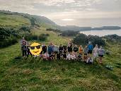
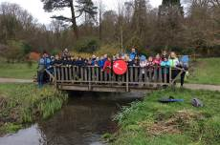
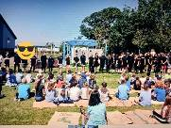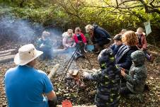

Implementing the

The Curriculum Vision

To let our children be children. | To treat all our children as individuals and develop their individual personalities and interests as well as developing a respect and understanding of others. | To provide an environment where no child is left behind and all children can achieve their full potential both academically, physically, socially and emotionally.
To provide an inspirational modern and relevant curriculum where children develop soft skills across all curriculum areas underpinned by a core set of values. | To provide a truly inclusive curriculum where difference is celebrated and children are supported and nurtured. | To provide a relevant curriculum that is irresistible, unforgettable, based on practical, real life experiences.
To be an inclusive school where we inspire and empower our children to learn. | To provide a stimulating, vibrant and exciting learning environment for all our children so that they feel happy and confident and are challenged to achieve excellence in everything they do. | To become the heart of the Johnston Community.

Implementation – How is the curriculum being delivered?

Curriculum content is relevant to the school’s community and the wider world. | Knowledge is organised into small steps in order to ensure it supports subsequent learning. | Teachers ensure that learning is purposeful and clear so that children are motivated and see there is a purpose. | Enquiry based questions are used to stimulate children’s natural curiosity. | Discrete teaching of basic skills e.g. phonics, times table | Questioning, using blooms, is evident in all lessons, providing challenge to all children. | Teachers model high expectations.
Challenge by choice is embedded to ensure there are no ceilings placed on the learning. | Children are empowered to make daily decisions about how and where they would like to learn. | Children can use their knowledge to improve their work and the work of others through critique. | Teachers monitor and assess children’s learning to ensure progression, consolidation and challenge in their learning. | Environmental stimuli, including trips and clubs, are used to enrich children’s experiences and engage them in their learning. | Curriculum teams monitor, moderate and provide support to ensure progression in skills and knowledge | Teachers use independent time to deliver targeted teaching to small groups of children or individuals.

Teachers know their children’s strengths, next steps, and preferred learning style so that lessons are targeted and specific. As part of the new curriculum R.E.A.L projects are planned to ensure there are opportunities for reasoning, analysis, critical thinking, and problem solving, encompassing the national curriculum requirements. As a school, we work in teams to ensure there is a broad and balanced curriculum that has a real-world context. This is delivered through educational visits, visitors, assemblies, extra-curricular activities, links to charities, links to the local & wider community.

How we have developed our outdoor learning Environment?
Outdoor learning has become fundamental to life at Johnston School. We use our wonderful grounds very effectively to enhance curriculum experiences.
Over the last three and a half years we have developed the field, into a fantastic resource for environmental studies and personal and social education. Pupils have named the field 'Maes Meithrin' for environmental studies and personal and social education. ​
We have made a long-term commitment to develop this area so that it provides rich and exciting learning opportunities for pupils. This area has been identified as best practice on a regional level and we supported schools from across Wales on how they can enhance pupils learning using the outdoors.
Maes Meithrin includes:
- A Sensory Garden
- A vegetable garden
- An orchard
- A poly tunnel
- Chickens
- Loose Parts Play
- A stream.
- A wild meadow
- Pizza oven/Kiln
- Willow sculptures
- Disabled access boardwalk to the fire pit
- A round house.

Each class now has an outdoor learning area which is used throughout the week. We believe that it is important that children apply the skills that they have used in a real-life context, and we frequently use the outdoors to do this.
The quality of outdoor learning provision has been recognised nationally, and we are in the process of becoming the only Leaf Education beacon school in Wales.

Safeguarding Responsibility
All staff are trained in Safeguarding with key staff roles as follows:
Designated Senior Lead for Child Protection:
Mr. Ross Williams (Headteacher)
Deputy Designated Lead for Chid Protection:
Mrs. Caroline Wood (Assistant Headteacher)
Mrs. Linda Greenish (Family Liaison Officer)

Pupils with Disabilities
Every effort is made to enable all pupils to play a full and active part in their time at school. The school building has complete disabled access. Resources for special provision are reviewed regularly to maximise the inclusion of all children. If you have any concerns or queries about additional support for your child, please contact Mr Adam Stephens (ALNCO) for further information.
​
Health and Safety
- Health and Safety reports are shared with the Governors at least termly.
- Risk Assessments are written for all visits/trips/visitors along with Risk Assessments for the school and other activities deemed appropriate.
- Year Six prefects act as ambassadors for Health and Safety and support daily outdoor checks for their own area and for the younger pupils.

The School Prospectus
The school prospectus provides detailed information for parents, carers and new pupils. It is updated annually with relevant changes including new dates and changes to staff. You can find the prospectus on our website or contact the school for a copy; www.johnstoncommunityprimaryschool.co.uk

Strategic Equality Scheme Action Plan and Disability Access Plan
The Strategic Equality Plan and Disability Access Plan are available in school and on the school website. These outline the key actions that are planned to ensure that all our pupils have equal access to all aspects of school life. These are reviewed annually at Full Governors Meetings.

Premises
Essential maintenance has been completed where necessary and there continues to be an on-going programme of non-essential maintenance work. Any emergency responsive repairs are reported immediately to PCC repairs and maintenance. There have been no significant building works during 2024-25.

Pupil Targets
Individual pupil targets are set annually through the annual statement review or, for some pupils, the Individual Development Plan (IDP) meeting. These are used termly in developing the pupil targets in their IDP. Annual targets are set for the school for attendance and pupil progress. Annual Review reports include individual pupil targets. Pupils from Years 2-6 carry out online personalised assessments each term, to aid teacher Professional Judgements and to identify plans moving forward. These are shared through Parent Consultations and formal reporting.

Destination of School Leavers
Most of our children transfer to Milford Secondary School, with some children transferring to other Secondary Schools due to their individual and family requirements/choice.

Asymmetric Friday
On Fridays, school finishes at 13:00. However, pupils are able to stay in school until 15:15 and engage with a range of activities.

All pupils are expected to be at school in time for the commencement of each session. However, at the beginning of each school day we strongly recommend that pupils do not arrive at school before 8.45 a.m. because staff supervision cannot be guaranteed before this time and gates are not opened. From 8.45 a.m. until 9.00 a.m. parents are requested to follow the one-way system around the school at the start and end of the school day and are able to accompany and collect their children directly to and from the classroom. The school gate will be locked at 9.00. School will be accessed via the reception for any latecomers. The school gate will be opened at the end of the school day at 3.15

After school provision
Many thanks to Mrs. Louise Jones, Miss Sarah Codd for continuing to provide an after-school club. If you would like your child to attend at any time during the year, please contact the School.

Promotion of Healthy Eating, Health and Hygiene
Healthy eating is promoted throughout the year through curriculum learning opportunities, outlined in our RSE code.
These experiences include children cooking meals. Healthy lunchboxes are encouraged. There is a constant availability of water from the water cooler and during dinner time in the dining hall.
School health checks remain a consistent feature for our younger pupils, and we work closely with external organisations to support this.
School dinners are prepared fresh, on site by our school cook. School dinners are carefully planned by Pembrokeshire County Council to ensure meals are balanced, nutritious and healthy.

Toilets
The school toilets are cleaned daily by the caretaker/cleaner. Soap is available at all times in classrooms and in the toilets and there are paper towels/ hand dryers. All pupils wash their hands when returning to class and prior to dinner time. There are toilet facilities for Nursery and Reception within the area of their classrooms. In the center of the building there are toilets for Years 1&2 and Key stage 2. LRC 1 & 2 also have their own toilet attached to each classroom) There are two staff toilets, a changing room/shower and a medical room. The toilets are maintained to the highest standards.

Web site: https://www.johnstoncommunityprimaryschool.co.uk/
Twitter@JohnstonPrimary

